HealthApp

Business Requirements Document

Project: HealthApp

Author(s): Tarun Dagar,

Riddhi Mhatre,

Vivek Karhale,

Sriharsha Mopidevi,

Fernando Hernandez,

Jigarkumar R Patel,

Aliaksandra Paliashchuk,

Nishith Desai

Table of Contents

1. Project Overview 2

1.1 Glossary of Terms 3

2. Document Information 3

2.1 Audience 4

3. Business Opportunity 4

3.1 Project Overview and Background 4

3.2 Current State Analysis 4

3.3 Future State Objectives 4

3.4 Stakeholders 5

4. Business Requirements 5

4.1 Business Scope 6

4.2 Detailed Business Requirements 6

4.3 External Data Feeds (Interfaces) 7

4.4 Non-Function Requirements 7

4.5 Business Risks 8

# **Project Overview**

This document describes the business/user requirements for the HealthApp applications that will provide the basis for the following project activities:

* Introducing business/user requirements
* Making test standards, test plans and Creating test specifications
* Devising solutions to project tasks and Creating remedies to project-related responsibilities
* Create a mobile application that would allow consumers to sign up for different subscription plans and get wholesome, simple-to-prepare items at their doorstep.
* Determining a clear beginning, a definite end, and an overview of what happens in between the project.
* Identifying project stakeholders, involves prioritising stakeholders according to their vested interests in the project as well as their overall impact and influence on the project
* Evaluating the degree to which the project succeeded

## 1.1 Glossary of Terms

| **Term** | **Definition** |
| --- | --- |
| Suppliers | Health App's supplier’s base covers health/fitness experts who will advertise and sell their services related to fitness and diet. |
| Customers | For the purposes of this document, customers refer to those that wish to take service from dietitians/fitness experts and track their health habits. |
| Graphical User Interface (GUI) | Refers to the actual presentation, and interactions, of the website when a person logs into and browses the webpage |
| Target Market | This is defined as the overall customer group that HealthApp is designed to serve |
| Quality of Life (QoL) features | This refers to making the website more accessible to customers and continually improving features of the website |
| Web Application | For the purposes of this project HealthApp will encompass a website with a future scope of mobile application |

# **Document Information**

## 2.1 Audience

|  |  |  |
| --- | --- | --- |
| **Name** | **Business Group** | **Role** |
| Dietitians, Fitness Trainers | Customer Acquisition/Sales Management | Partner/Supplier |
| Third party Authentication Agencies | Customer Acquisition/Sales Management | Supplier |
| Payment Merchants | Finance/Account Management | Partner/Supplier |
| Customers (Fitness/Health enthusiasts) | Orders & Delivery Department, Customer’s Service Department | Web Application Users |

# **Business Opportunity**

## 3.1 Project Overview and Background

Our goal is to create an application that will provide users with a user-friendly platform that will allow them to connect and purchase services from the dietitians and fitness trainers to achieve their fitness goals. It will also serve as a platform for health habits tracking. With this platform we want to narrow the gap between customers and fitness trainers/dietitians, and combine the services such as diet plans, exercise schedules, fitness tracking and supplements information on a single platform.

## 3.2 Current State Analysis

The HealthApp is in progress of becoming a convenient platform for health and fitness/diet habits tracking and health improvement. Once our customers get comfortable with the tracking service, they will consider hiring a professional dietitian/fitness trainer through our app, which will lead them to another service HealthApp will offer. It will include an opportunity for our customers to connect with and hire professional dietitians and fitness trainers and improve/speed up their fitness/diet progress. The planning process for the application is currently underway, and the development of the project will span two semesters at Pace University.

## 3.3 Fut**ure State Objectives**

Our objective is to create a well-organized platform that will be able to compete with such a big and diverse health apps market. The application will offer to our customers a combined services tool that will have both the tracking system and the fitness/dietitian search/connect platform. At the end of the development process, we want to see a perfect and convenient tool that will attract not only professional health enthusiasts and athletes, but also beginners planning to improve their health and physique.

**3.4 Stakeholders**

|  |
| --- |
| Customers (Health Enthusiasts) |
| Dietitians/Fitness Trainers |
| Customer support team |
| Advertising/Marketing Team |
| Customer Acquisition/Sales Team |
| Finance/Account management Team |
| Advertising Agencies |
| Payment Partners |
| Third party authentication agencies |
| Brand Partners (If collaborated with any) |

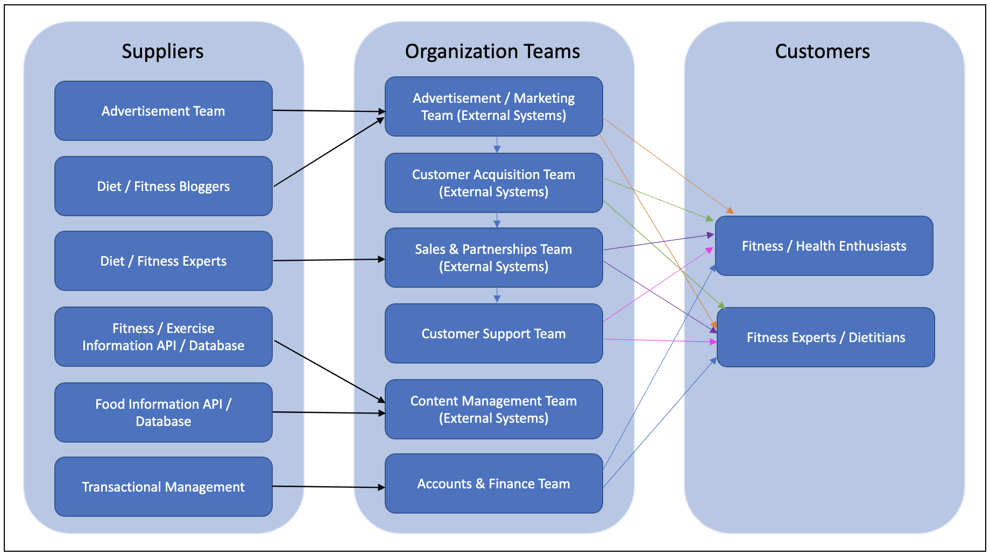

# **Business Requirements**

## 4.1 Business Scope

The targeted users of this application will be able to create an account and track their diet, as well as fitness progress free of charge on this portal. For various specific services provided by dietitians and fitness trainers, according to the needs of customers and availability from dietitians/trainers, the customer must pay. The application will offer a user-friendly interface which will give the users an opportunity to search, connect and hire various dietitians/fitness trainers to fulfill their goals and subscribe to the preferred diet and/or fitness program. The portal will have the ability to track users’ daily diet/exercises which may be shared with trainers/dietitians and used by them to provide feedback as well as progress reports. Along with the above, for a certain price, health product suppliers can advertise their health-related products.

## 4.2 Detailed Business Requirements

**4.2.1 Requirements of Customers**

4.2.1.1 Ability to sign up/register

4.2.1.2 Ability sign-in/sign out to the platform

4.2.1.3 Ability to delete their account

4.2.1.4 Ability to modify password with validation

4.2.1.5 Ability to modify account data

4.2.1.6 Ability to measure calorific value of diet

4.2.1.7 Ability to search/connect with dietitians/fitness trainers

4.2.1.8 Ability to subscribe to diet/exercise plan

4.2.1.9 Ability to cancel the subscription

4.2.1.10 Ability to enter/track diet/exercise details

4.2.1.11 Ability to give feedback and ratings to products and services they have used

4.2.1.12 Ability to contact customer support services

**4.2.2 Dietitians/Fitness Trainers requirements**

4.2.2.1 Ability to sign up as dietitians/fitness trainer

4.2.2.2 Ability to sign in/sign out on platform

4.2.2.3 Ability to modify the password

4.2.2.4 Ability to provide their availability on the portal

4.2.2.5 Ability to create/modify diet/exercise plans for the subscribed customers

4.2.2.6 Ability to track progress of subscribed customers

4.2.2.7 Ability to provide feedback to the subscribed customers

4.2.2.8 Ability to modify their account data

4.2.2.9 Ability to contact customer support services

4.2.2.10 Ability to schedule and conduct online sessions with customers

**4.2.3 Finance/Account Management team**

4.2.3.1 Ability to provide authentication of the payment details

4.2.3.2 Ability to issue refunds

4.2.3.3 Ability to provide details of processed payment

4.2.3.4 Ability to process the plan subscription payments

4.2.3.5 Ability to apply/issue discounts

4.2.3.6 Ability to manage payments process to Dietitians/Fitness Trainers

4.2.3.7 Ability to resolve issues related to a problem in the payment of invoices

4.2.3.8 Ability to resolve issues of advertisers/product sellers

**4.2.4 Customer Support Services Team**

4.2.4.1 Ability to provide solutions for received customer complaints

4.2.4.2 Ability to modify system details required to resolve the issue

4.2.4.3 Ability to resolve issues of advertisers/product sellers

## 4.3 External Data Feeds (Interfaces)

**4.3.1 Customer Services System**

4.3.1.1 Form submission that the customers can use to contact customer service, submit the complaints for resolution and get answers to their inquiries.

4.3.1.2 Allows the customer service department system to feed the information to the client’s account on HealthPlan with the answers to customer’s information inquiries and update the clients on their submitted complaints by providing the information received from the source of the issue and providing the resolution.

**4.3.2 Payment Gateway System**

4.3.2.1 Enables the customers to pay for the services subscribed to and pay for the products bought from application by processing the payment by authenticating and charging the credit cards or other payment means.

4.3.2.2 Enables the customers to receive the refunds in case the order got lost or there is an issue with the products in the order by processing the refunds by crediting back the funds.

**4.3.3 Third party Authentication – Google**

4.3.3.1 For creating the account on portal without form submission by authenticating details from third party agencies like Google.

4.3.3.2 Receive details from third party agencies without compromising customer’s privacy.

**4.3.4 Ads Platform System**

4.3.4.1 Feeding the application with the sponsored posts, the contract length, and costs of the advertisements

4.3.4.2 HealthPlan will be generating reports for trend analysts and feed the Ads Platform system with the data on product performance and market analysis.

**4.3.5 Nutrition's System**

4.3.5.1 Feeding the application with the food information using an external API that provides two endpoints: the Food Search endpoint, which returns foods that match desired search criteria, and the Food Details endpoint, which returns details on a particular food.

**4.3.6 Exercises Systems**

4.3.6.1 Feeding the application with list of thousands of exercises targeting every major muscle group. Using this information, we can share a variety of exercises for users to create their routines, based on the descriptions of the exercises.

## 4.4 Non-Function Requirements

|  |  |
| --- | --- |
| **Category** | **Requirements** |
| **Usability** | The application GUI will provide a user-friendly intuitive design with all the features clearly displayed for the user |
| **Usability** | The application navigation will be self-explanatory by clear and concise descriptions and names of each section, as well as features will be clear by proper location and naming |
| **Usability** | Accessibility will be supported for the disabled users as well |
| **Performance** | The application will be supported on different operating systems and mobile devices, and should not impact the user’s system capabilities |
| **Performance** | The application will be available 24/7 without any interruptions, and regular maintenance will be scheduled to support the application |
| **Performance** | The application will support the concurrency where the users will be able to simultaneously browse the app, login & subscribe, make payments, shop the products |
| **Performance** | The application will have a short response time to all requests and all the features should be available and not impacted by latency |
| **Security** | The application will be using the automated daily & weekly audits to detect vulnerabilities. |
| **Security** | The application will use HTTPS protocols for any data exchanges, enforced TLS for all the email communications, and other encryptions that will be maintained on the server |
| **Database** | The application will be using the PostgreSQL database |
| **External System** | The application will be able to interface with the external data feeds from and to payment merchants, ad agencies, social media websites, food service APIs, Exercise tracking APIs, etc.... |

## 4.5 Business Risks

Our application is targeting a market space of health enthusiasts who want to live a healthier life and have an efficient way to track their health goals. Much of the competition for our business is established and popular fitness and diet apps, and being a new heath app on the market will make the business face a lot of obstacles. To eliminate the competition risks, HealthApp will offer competitive advantages in existing market niches by combining fitness and diet tracking on the same platform. The combination of these two tracking services will keep users from switching between several apps, save their time/money and keep them devoted to the platform. In addition, by providing our customers with an opportunity to search/connect and hire fitness trainers/dietitians, HealthApp is becoming a one-of-a-kind, universal, platform for effectively achieving any health enthusiasts’ goals. As in any other business, there are more risks associated with the platform such as compliance, legal and reputational risks. To mitigate compliance and legal risks, everyone who will sign up for a fitness trailer or dietitian will have to sign a waiver and agree to the terms and conditions of the app. Reputational risks will be lowered due to the review system that will help our platform eliminate all the disreputable fitness trainers and dietitians.

From the technical perspective the company can face the risk of software malfunctioning and cyber-attacks. There is a constant concern of vulnerabilities such as SQL Injection (SQLI), Cross-Site Scripting (XSS), Traversal Directory (TRV), Local File Inclusion (LFI) and Remote File Inclusion (RFI), Shell Code Injection, Directory Indexing (DI), Open Redirect (ORED), File Discover (FD), Common Vulnerabilities & Exposures (CVE) and others. The application will be subjected to automated daily & weekly audits to detect the vulnerabilities. It will also use HTTPS protocols for any data exchanges, enforced TLS for all the email communications, and other encryptions that will be maintained on the server. There is also a risk of application not being able to adapt to the innovative technologies fast enough to support the applications and stay competitive on the market. Maintaining and reusing the requirements and following the AORA will help our business to adapt faster to changes and develop new and upgraded features with ease and without wasting time on starting the projects from scratch.